**Learning:**

* Determining the strain values that would be measured by a strain rosette mounted on the bike crank
* Verifying the finite-element results from Ansys by comparing it with hand calculations using Euler-Bernoulli beam theory

### Problem:

we will consider adding a strain rosette to the bike crank to predict the strain. The rosette is placed along the top edge on the front face of the crank, midway between the support hole and the loaded hole as shown below.

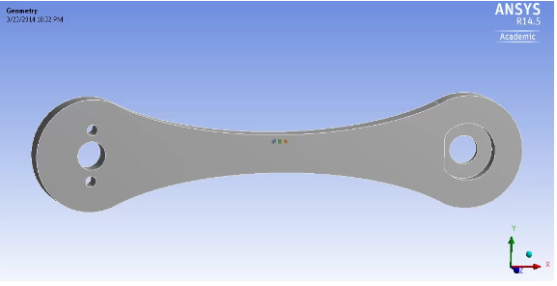

The location of the gauge centers with respect to a coordinate system centered at the front face of the support hole is as follows:

**Left Gauge:** (3.244 in, 0.219 in)

**Middle Gauge:** (3.346 in, 0.219 in)

**Right Gauge:** (3.448 in, 0.219 in)  
  
The rosette dimensions are shown in the figure below.

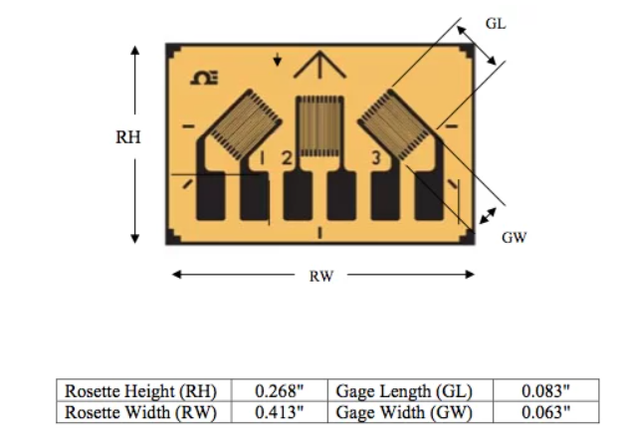

Determine the strain value that would be measured by each gauge on the rosette. Each gauge measures the extensional strain along its length (the longer dimension).

